Ecommerce website using the AWS services

The domain of the Project:

G5 CC : Cloud computing and Devops

Team Mentors (and their designation):

Mrs. Shreya Nagraj

Team Members:
- Sivaranjani Mahendhiren - B.Tech Artificial Intelligence and data science,smvec, ^{3rd} year pursuing

Period of the project

April 2023 to August 2023

Declaration
The project titled “Ecommerce website using AWS services” has been mentored by Ms. Shreya , organised by SURE Trust, from April 2023 to August 2023, for the benefit of the educated unemployed rural youth for gaining hands-on experience in working on industry relevant projects that would take them closer to the prospective employer. I declare that to the best of my knowledge the members of the team mentioned below, have worked on it successfully and enhanced their practical knowledge in the domain.

Team Members:
- Miss. Sivaranjani Mahendhiren

Mentor’s Name Mentor’s Name
Designation—Company Name Designation—Company Name

Prof. Radhakumari
Executive Director & Founder
SURE Trust

Table of contents
- Executive summary
- Introduction
- Project Objectives
- Methodology & Results
- Social / Industry relevance of the project
- Learning & Reflection
- Future Scope & Conclusion

Executive Summary
A concise overview of the project's objectives, methods, key findings, and recommendations.
Objectives: Build a minimal, serverless e-commerce platform (Angadi) with secure authentication, personalized user experience, and scalable architecture.
Methods: Implemented using AWS services (Cognito, S3, DynamoDB, Lambda, Amplify, AppSync GraphQL) with Razorpay for payments and ML models for product recommendations & sentiment analysis.
Key Findings:
- Serverless design ensured scalability and cost-efficiency.
- GraphQL + DynamoDB enabled seamless user-specific data handling.
- ML integration improved personalization and product insights.
Recommendations:
- Enhance with real-time analytics dashboards.
- Expand ML models for advanced recommendations.
- Integrate monitoring (CloudWatch) for better system health tracking.

Highlights the most important aspects of the project for executives or stakeholders.
- Serverless E-Commerce Platform → Built entirely on AWS (Cognito, S3, DynamoDB, Amplify, Lambda, AppSync).
- Secure & Scalable → User authentication with Cognito, serverless hosting via Amplify, and pay-as-you-go scalability.
- Personalized Experience → Users can buy, sell, and interact with products; data stored per user in DynamoDB.
- Seamless Payments → Razorpay API integration for quick and secure transactions.
- AI-Driven Features → ML models (via Lambda) enable product recommendations and sentiment analysis of reviews.
- Business Value → Low-cost, scalable platform with intelligent personalization to drive user engagement and retention.

Introduction
Background and context of the project
Background
E-commerce platforms are growing rapidly, but many require heavy infrastructure and high maintenance costs. To address this, the project aimed to design a lightweight, serverless, and cost-efficient platform using AWS services.

Context
The project, named Angadi, leverages AWS (Cognito, S3, DynamoDB, Amplify, Lambda, AppSync) and Razorpay to build a secure, scalable, and AI-driven marketplace. It enables users to buy, sell, and interact with products while benefiting from personalized recommendations and sentiment analysis.

Problem statement or goals of the project
Problem Statement
Traditional e-commerce solutions often demand complex infrastructure, high costs, and limited personalization, making them less practical for small or independent businesses to adopt.
Goals
- Build a minimal, serverless e-commerce platform with low maintenance and scalability.
- Ensure secure authentication, storage, and transactions.
- Enable user-specific personalization for carts, orders, and product interactions.
- Integrate ML-driven recommendations and sentiment analysis to enhance user experience.
- Serve as a replicable model for small businesses ("shoppies") to quickly create their own minimal e-commerce sites.

Scope and limitations of the project
Scope
- Development of a serverless e-commerce platform (Angadi) using AWS services.
- Features include user authentication, product listing, cart, orders, likes, and order tracking.
- Integration of Razorpay for secure payments.
- AI/ML functions via Lambda for product recommendations and sentiment analysis.
- Designed as a scalable model for small businesses to adopt minimal e-commerce solutions.
Limitations
- Limited to basic e-commerce functionalities (no advanced ERP or logistics integration).
- Razorpay dependency restricts payment methods to supported regions.
- ML models are basic and may require further tuning for large-scale deployments.
- Does not include real-time analytics dashboards or advanced fraud detection.

Innovation component in the project
- Serverless-first design → Eliminates traditional infrastructure needs, reducing cost and complexity.
- User-as-seller model → Allows users to not only buy but also list and sell their own products.
- AI/ML Integration → Product recommendations and sentiment analysis via AWS Lambda for personalized shopping.
- Replicable framework → Serves as a ready-to-use model for small shops ("shoppies") to quickly launch minimal e-commerce platforms.

Project Objectives
Clearly defined objectives and goals of the project
Objectives
- To design and implement a minimal, serverless e-commerce platform using AWS services.
- To provide a secure, scalable, and cost-efficient solution for online retail.
- To demonstrate the use of cloud-native technologies and AI/ML in enhancing user experience.
Goals
- Enable secure authentication, product management, and transactions.
- Provide personalized user experiences through carts, orders, likes, and recommendations.
- Integrate Razorpay for seamless payments.
- Use ML models for product recommendations and sentiment scoring.
- Deliver a replicable model for small businesses ("shoppies") to easily launch their own e-commerce platforms.

Expected outcomes and deliverables.
Expected Outcomes
- A fully functional serverless e-commerce platform (Angadi) hosted on AWS.
- Secure user authentication and data handling with Cognito and DynamoDB.
- Seamless product browsing, cart management, order tracking, and payments.
- Personalized shopping experience with ML-driven recommendations and sentiment analysis.
- A scalable and cost-efficient model that can be adapted by small businesses.
Deliverables
- Deployed web application hosted on AWS Amplify.
- DynamoDB database with user-specific interactions and product data.
- Integrated Razorpay payment gateway.
- Lambda-based ML models for recommendation and sentiment scoring.
- Project documentation including architecture, workflows, and usage guide.

Methodology and Results
Methods/Technology used
Technologies Used
- Frontend: React.js, HTML, CSS, JavaScript
- Authentication: AWS Cognito
- Storage: Amazon S3
- Database: Amazon DynamoDB
- API Layer: AWS AppSync (GraphQL)
- Backend Functions: AWS Lambda
- Deployment & Hosting: AWS Amplify
- Payment Gateway: Razorpay API

Tools/Software used
- Visual Studio Code (VS Code) → Code development and debugging
- AWS Amplify CLI → Deployment and hosting management
- AWS Management Console → Service configuration and monitoring
- Git & GitHub → Version control and collaboration
- Razorpay Dashboard → Payment gateway setup and testing

Data collection approach
- User-Generated Data: Collected through user interactions such as product listings, likes, cart updates, and orders, stored in DynamoDB.
- Product Data: Added by sellers/users directly via the platform, including details and images stored in S3.
- Feedback & Reviews: Collected from users to perform sentiment analysis using Lambda-based ML models.
- Transaction Data: Captured through Razorpay API for order and payment tracking.

Project Architecture
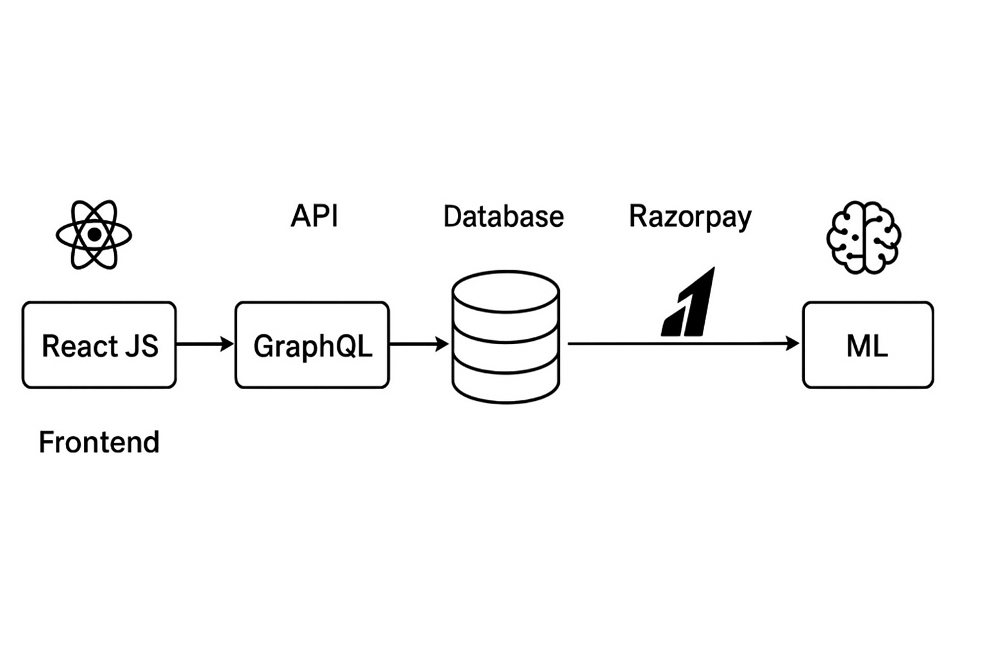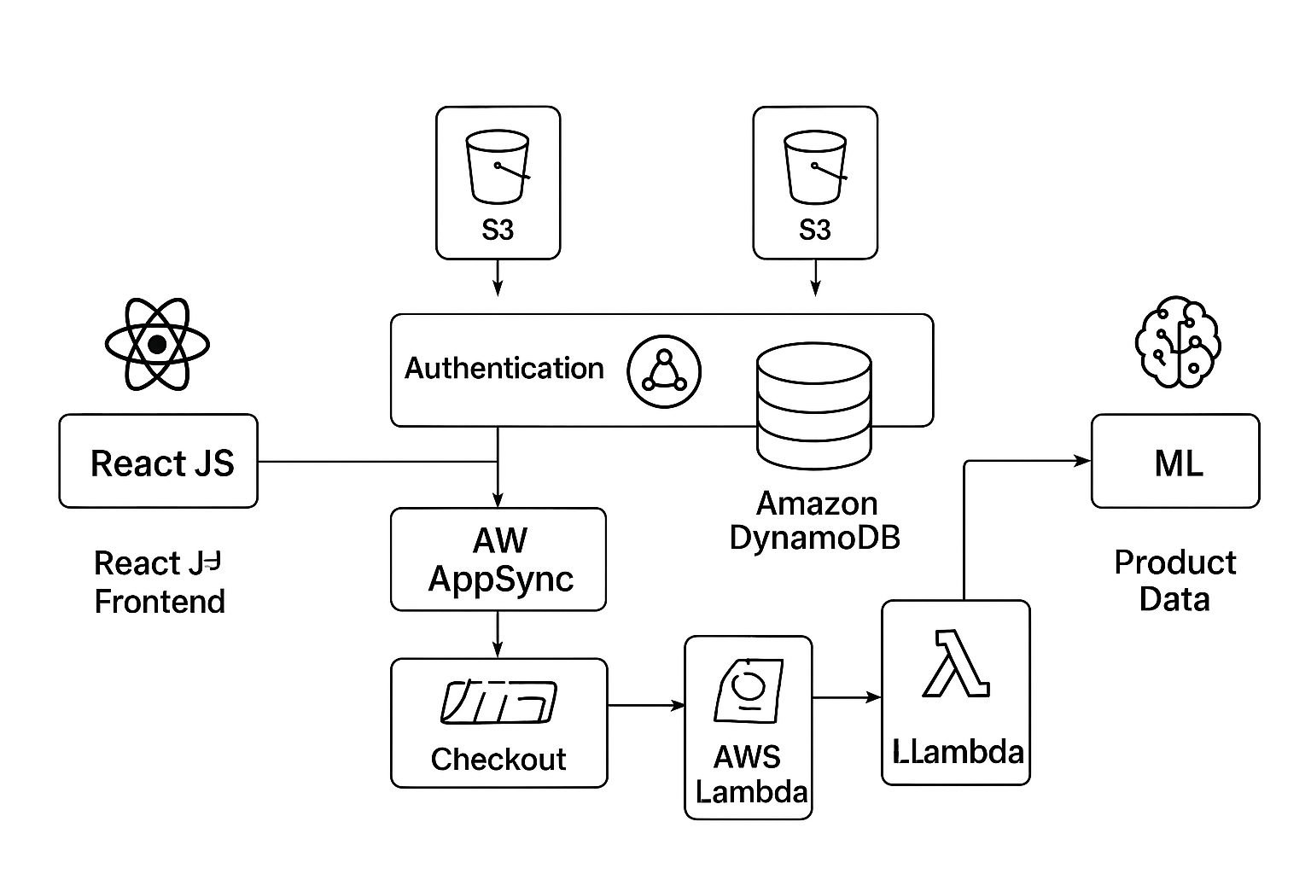
Final project working screenshots along with supporting explanation
Create account or sign in if already have an account
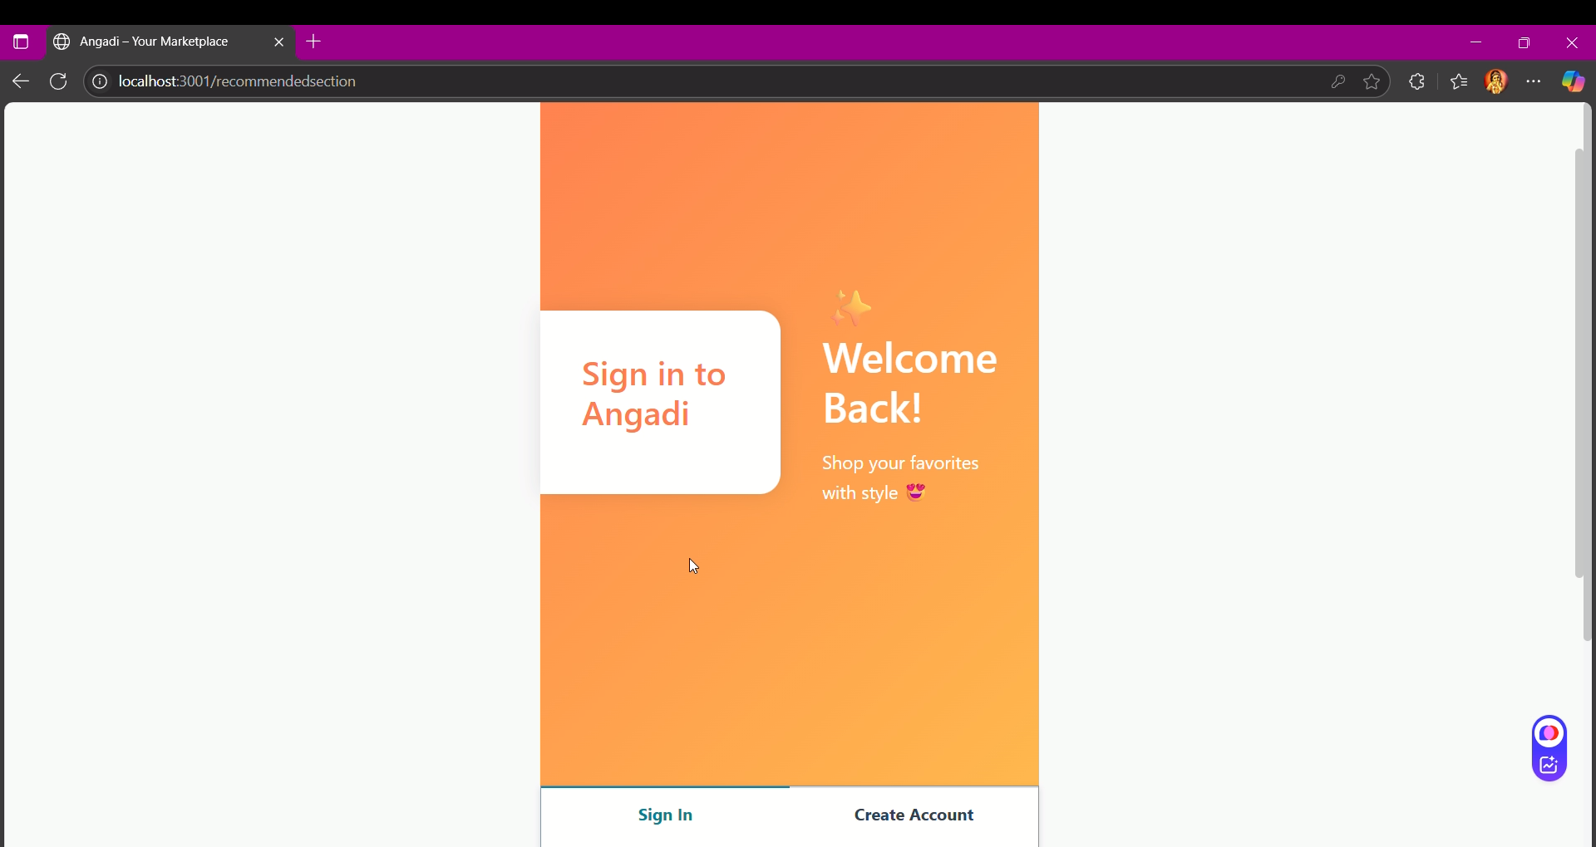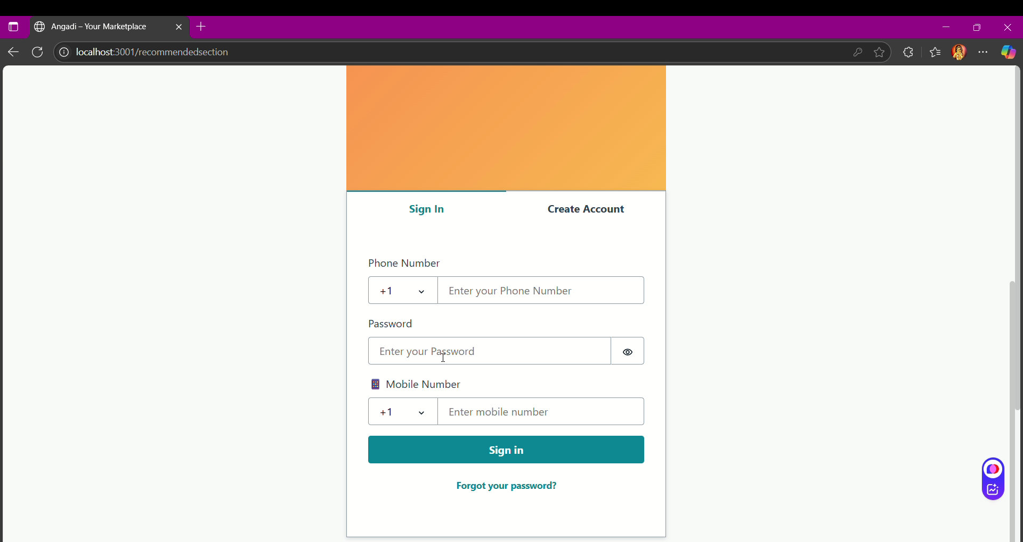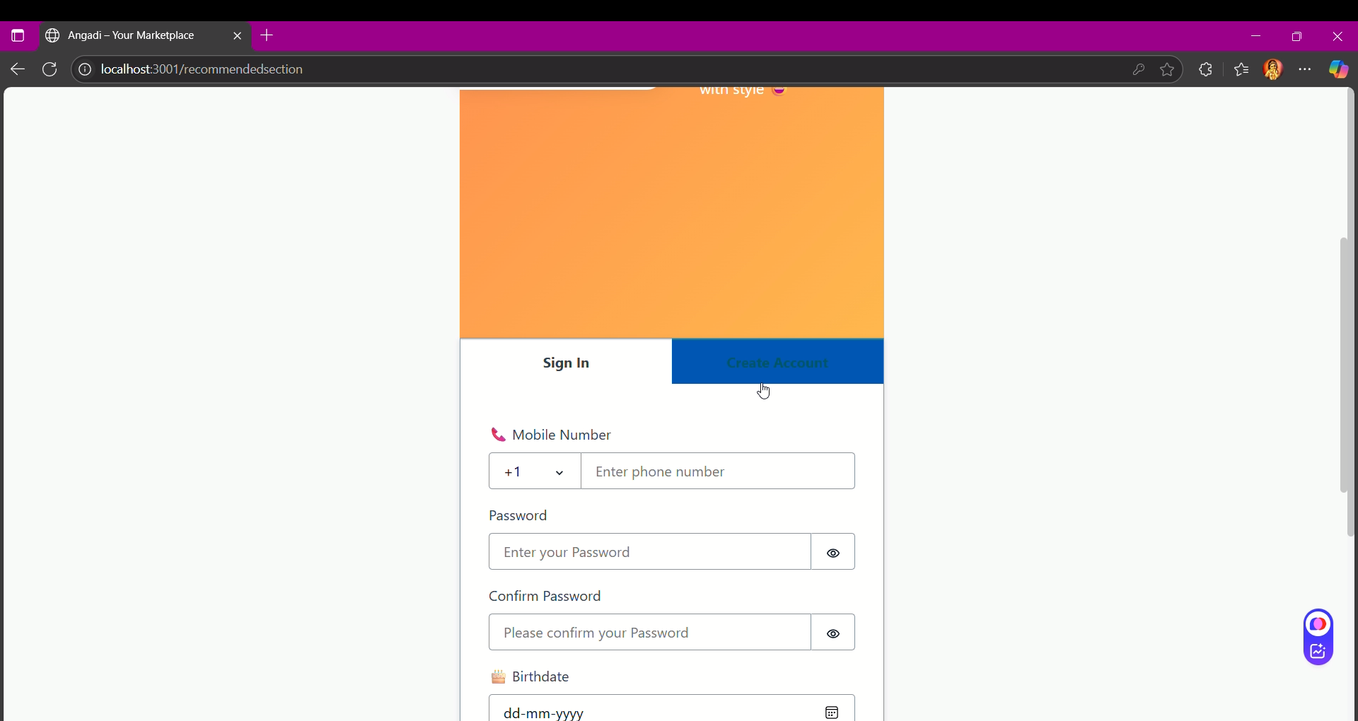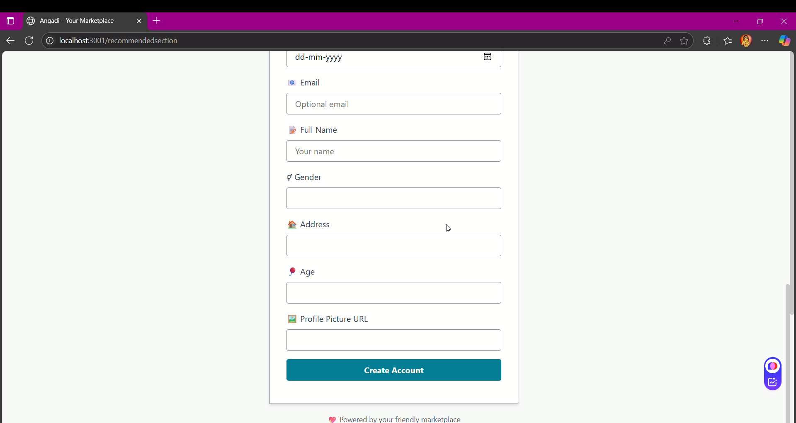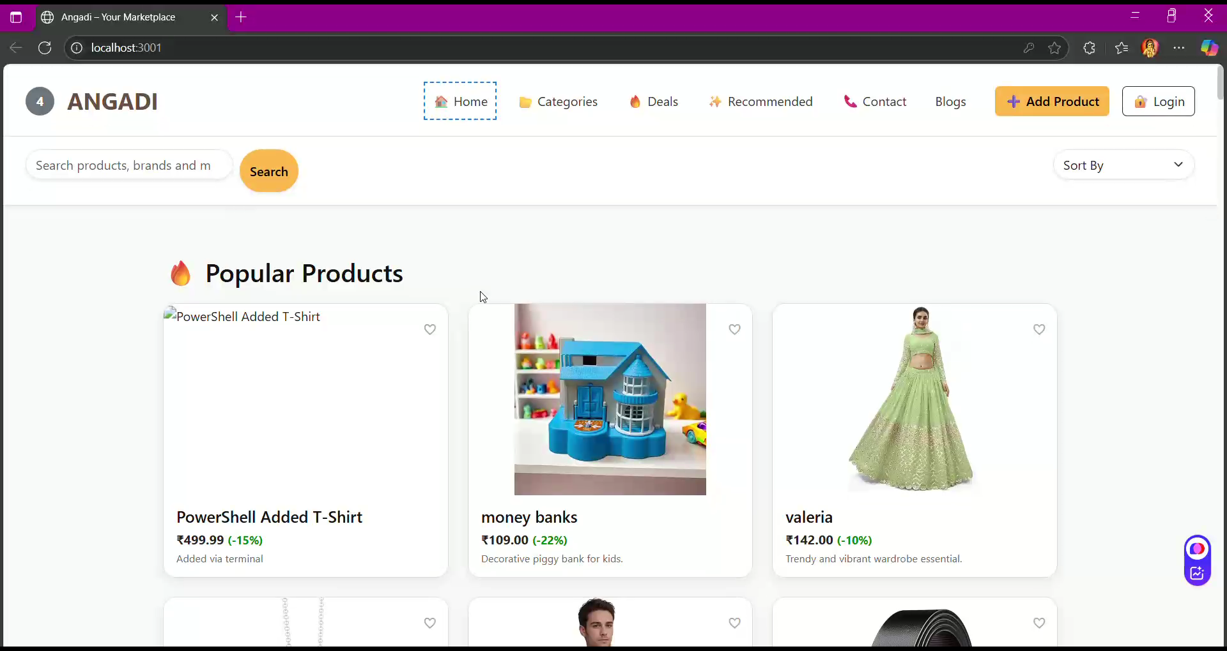
Here it is the landing page of our website here you can view all the products , search over and view by sorting out as well
- 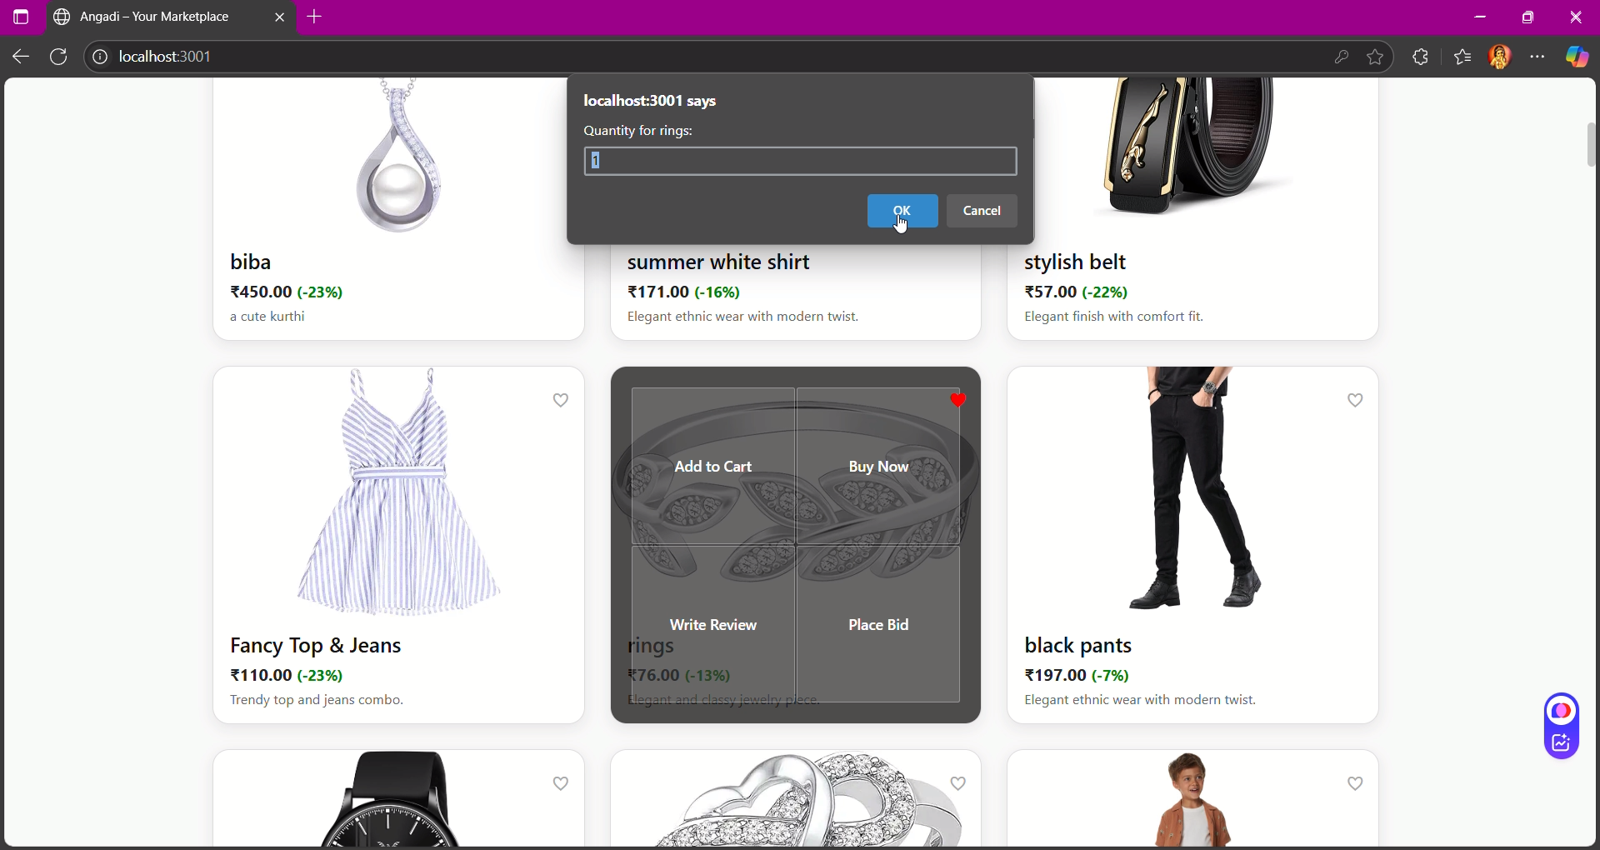
- Ordering the products asking for quantity of products to buy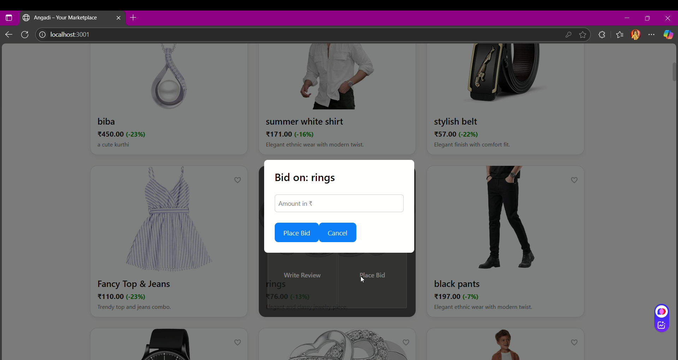
- You can bid over any product to the seller
- 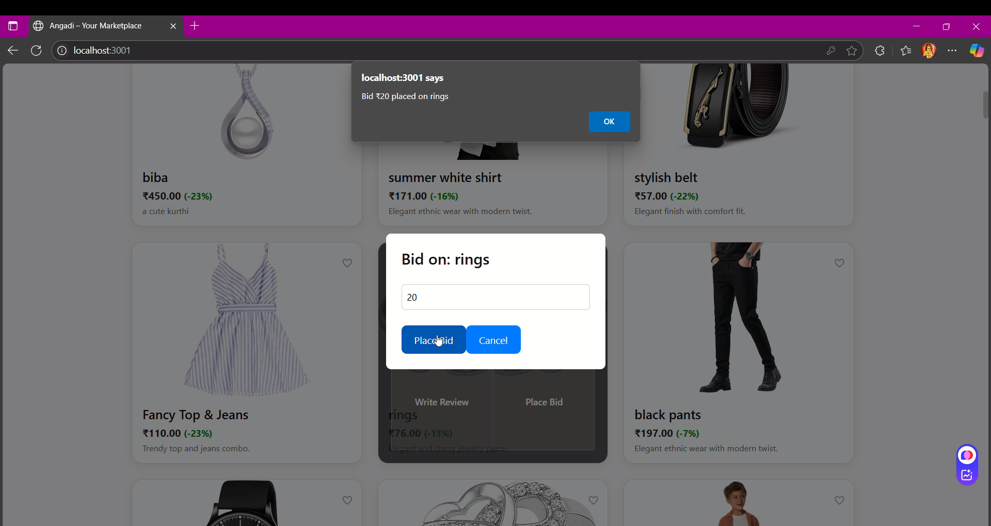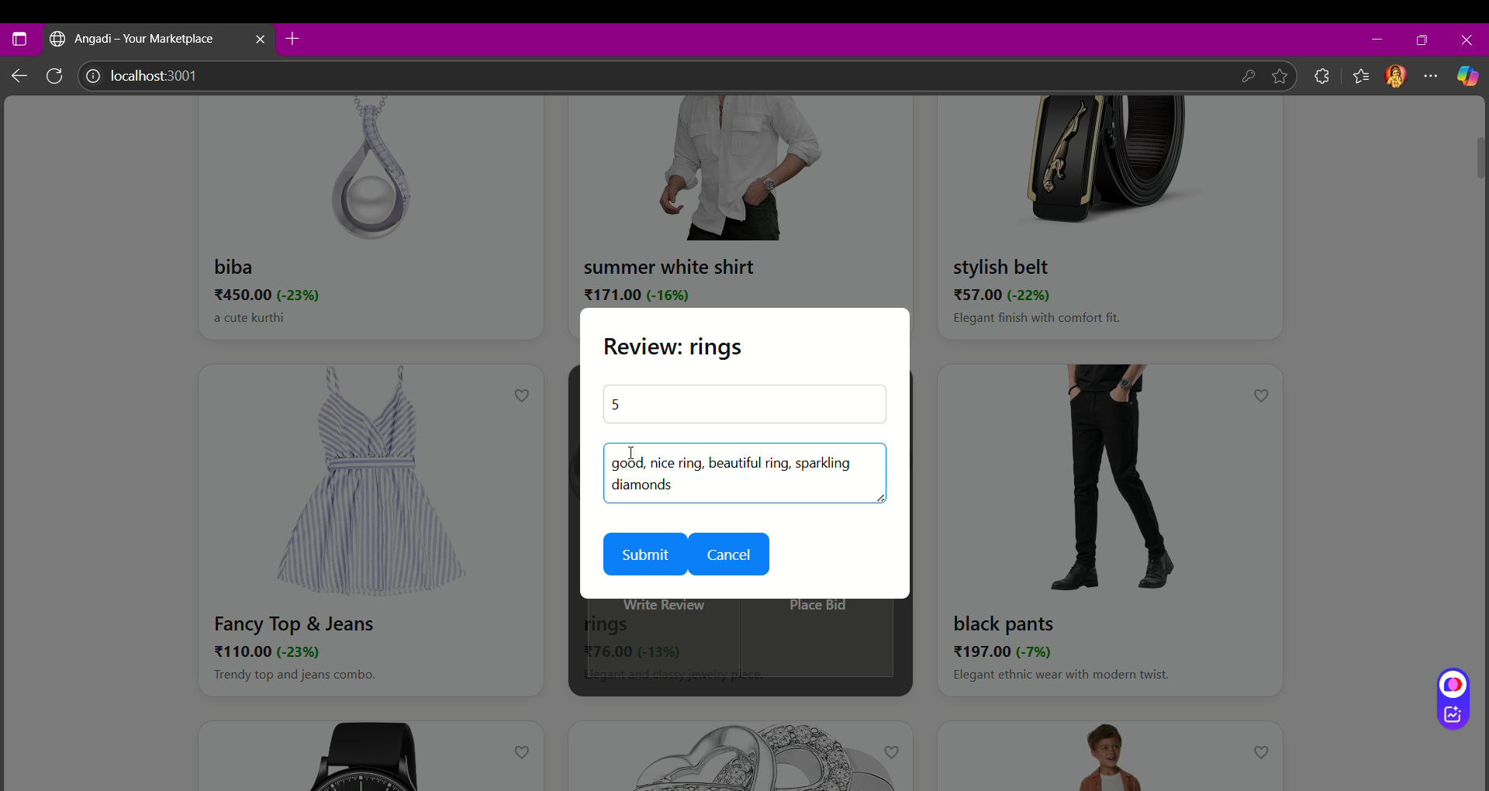
- To write reviews of the products what you think , it will help to score the products 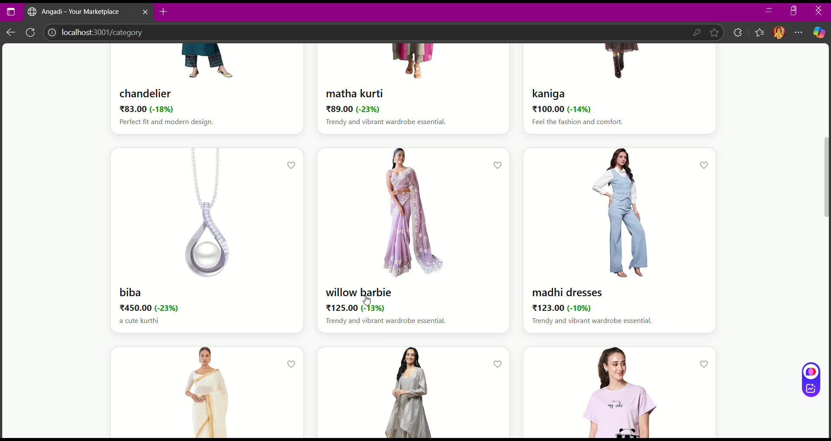 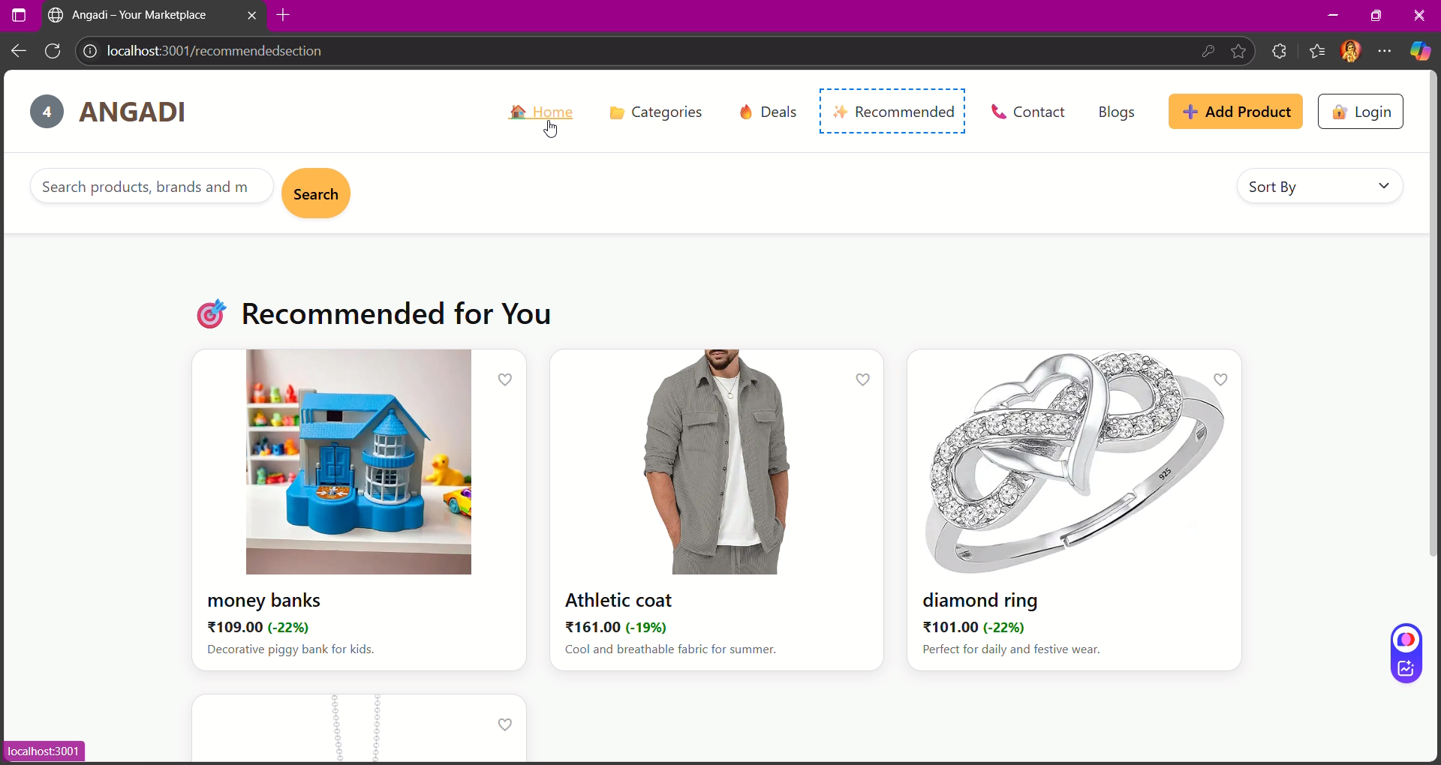
- In this section you can see the products recommended for you that is done by the ml model we have made via lambda . 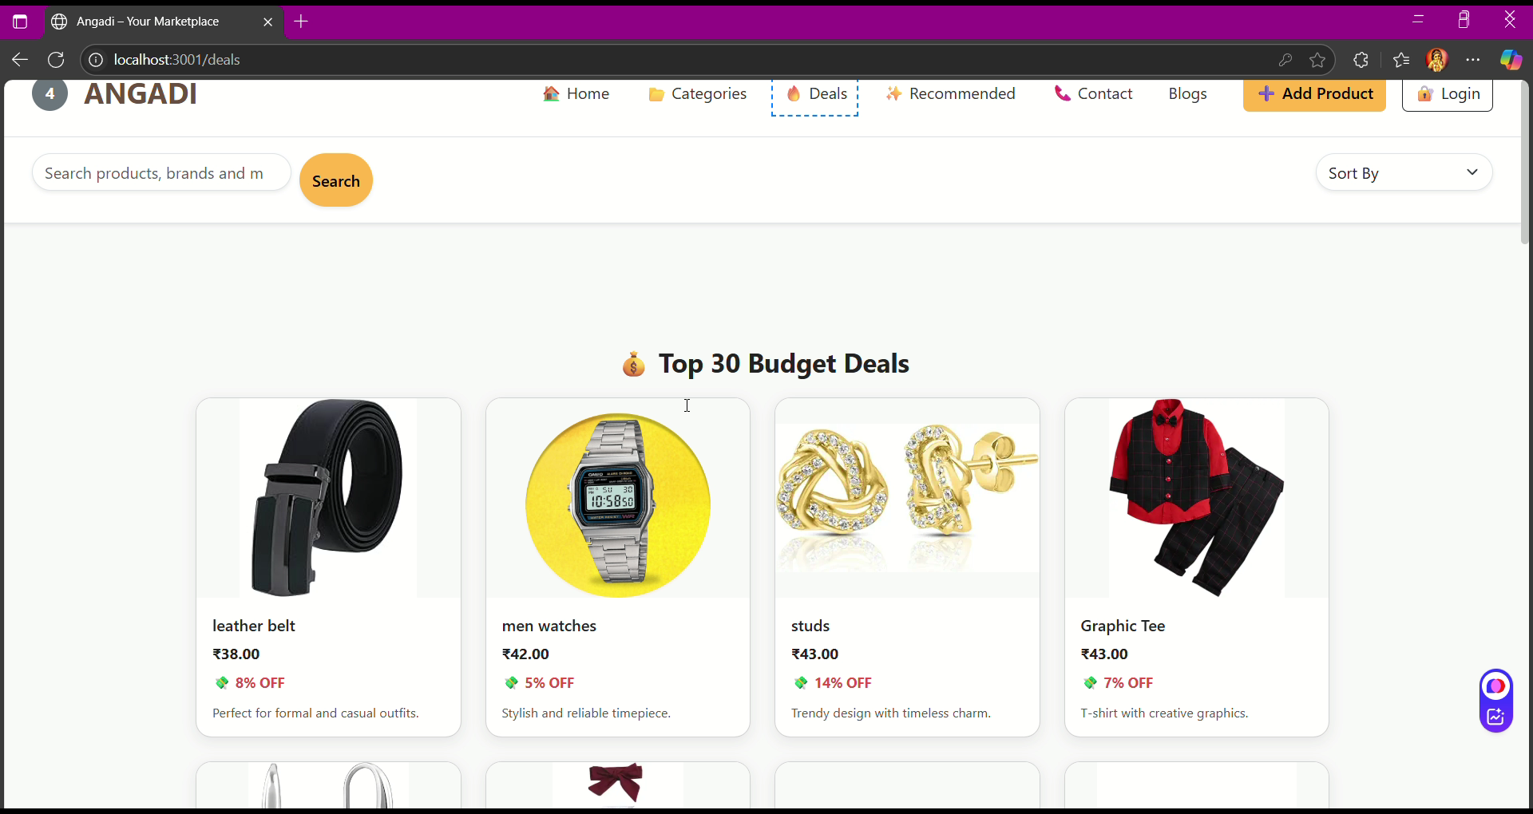
- The top 30 products with less price and so on 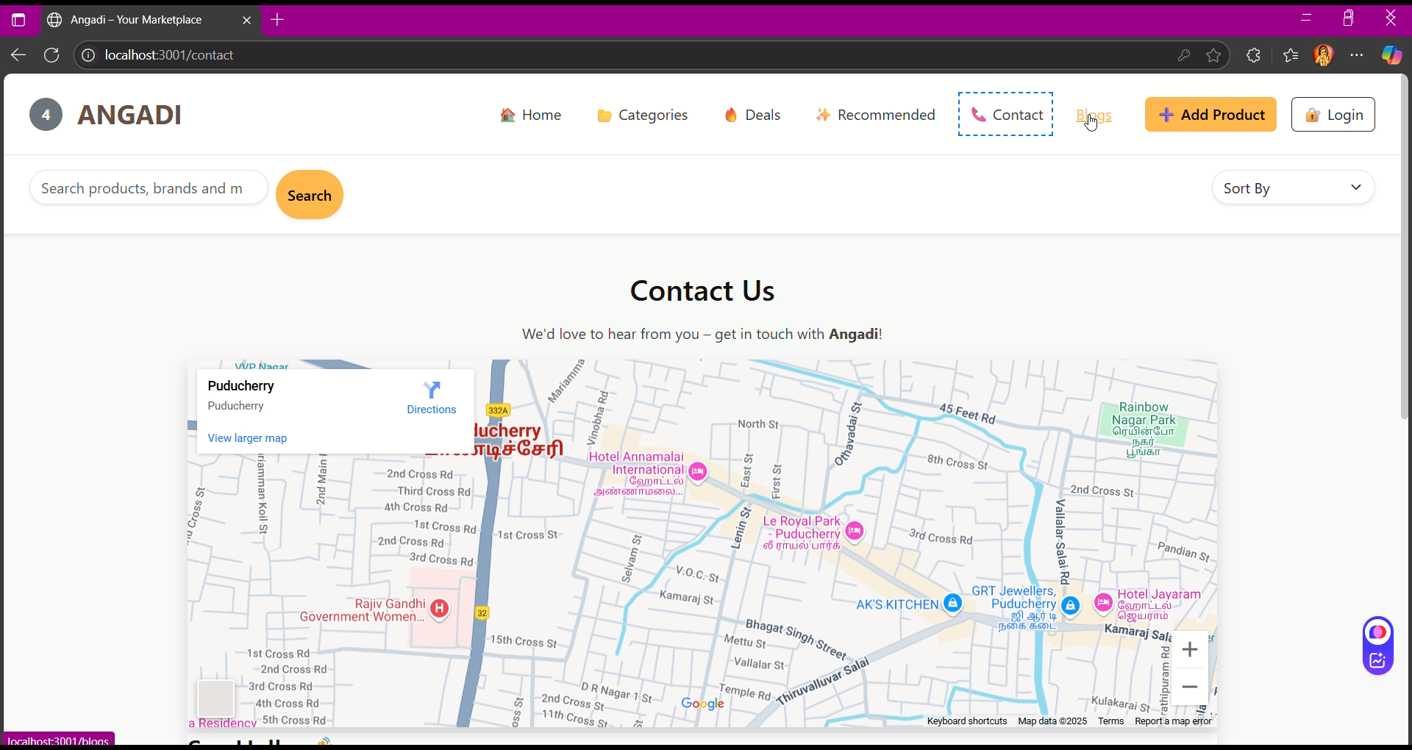
- Here you can glide over our support and contact details 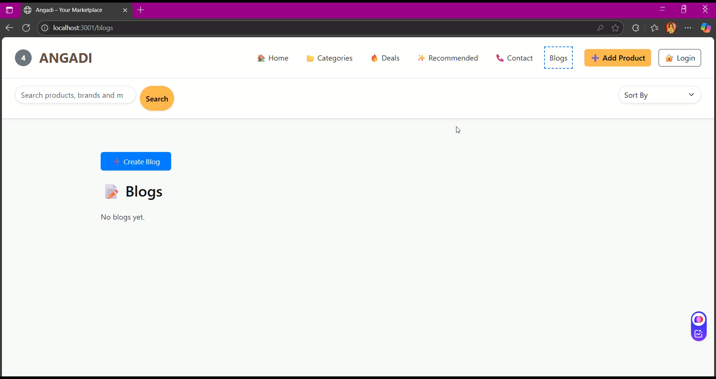
- Here you can add any blogs about the product or write about it like in social media , you can marketing here as well live marketing.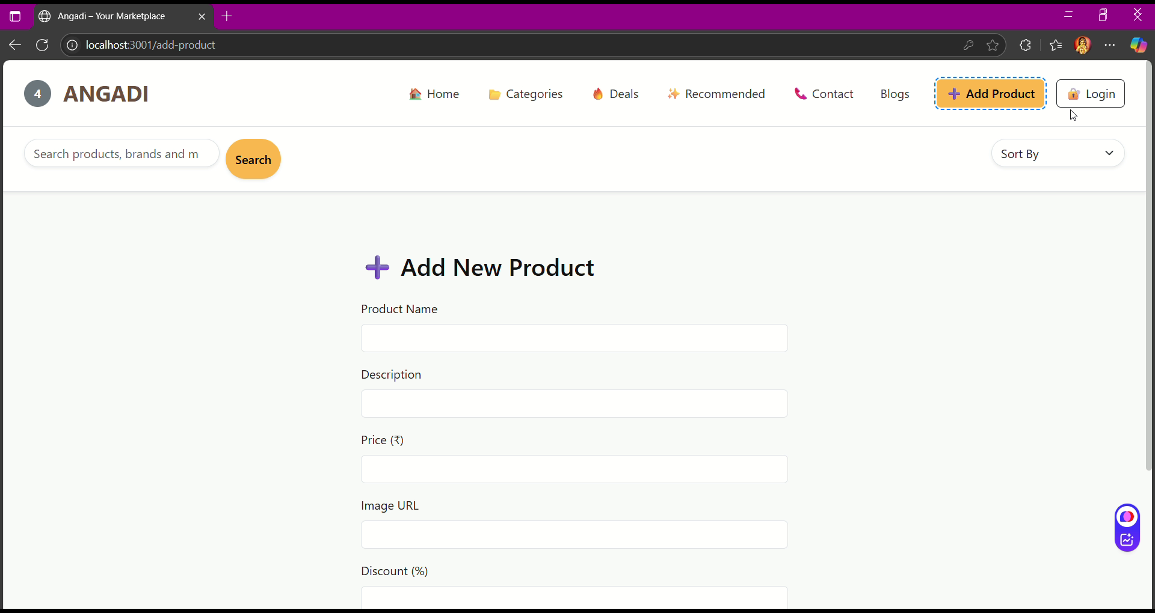
- Here you can add the product you wanna sell in our site as well 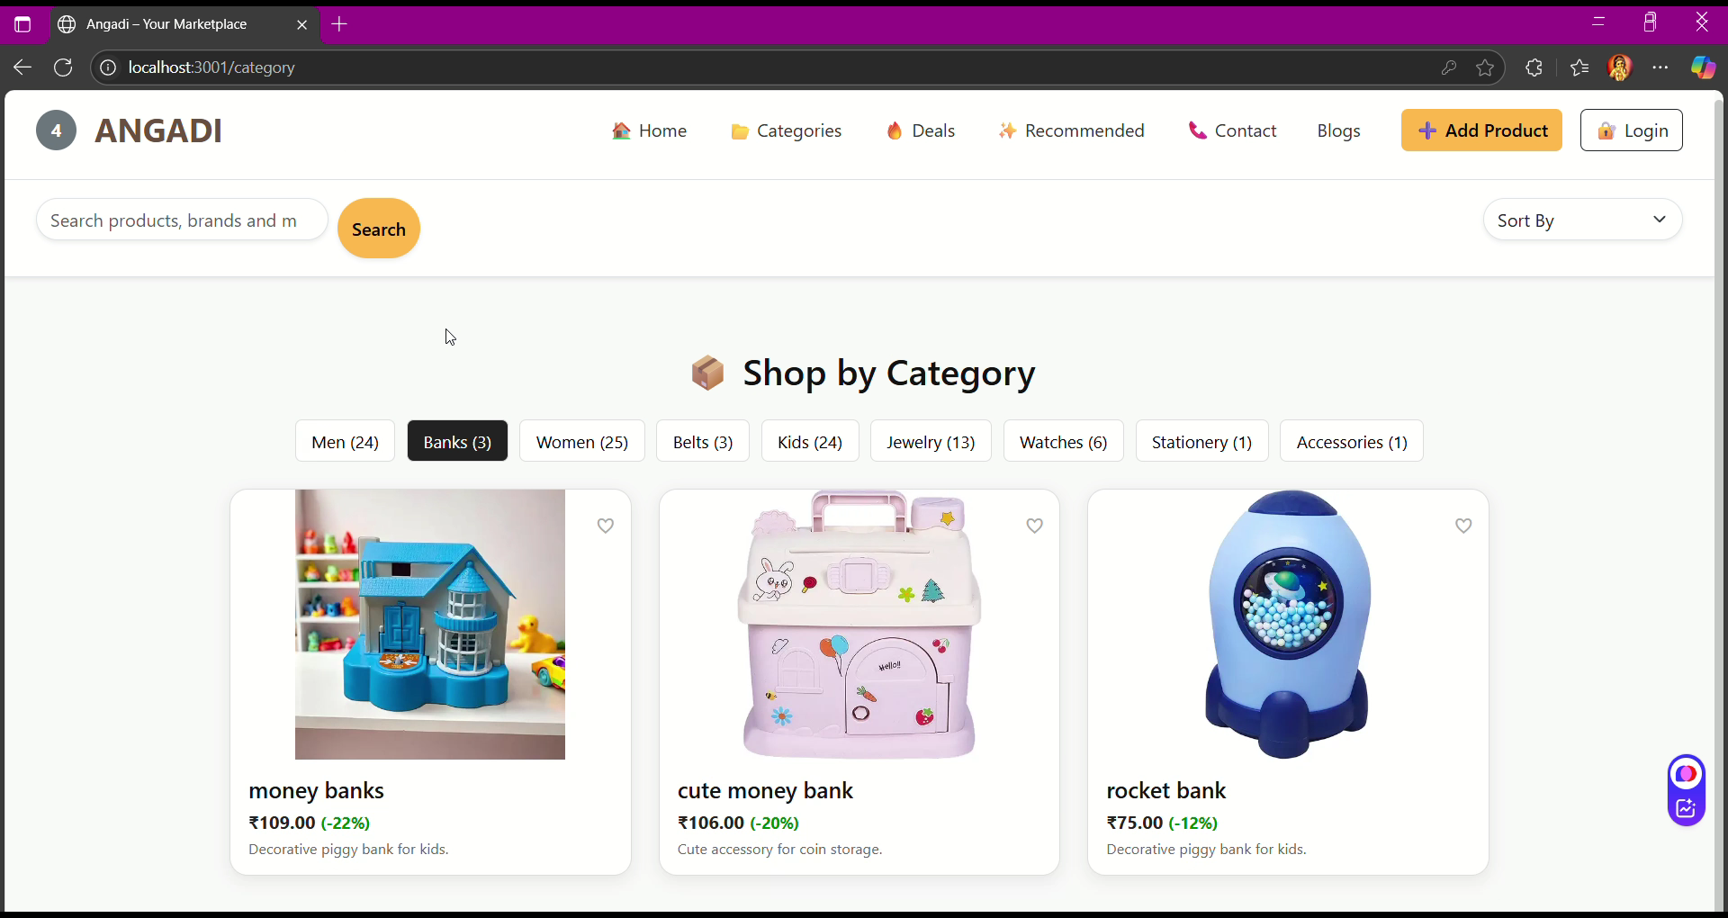
- Here you can see products over catgories .

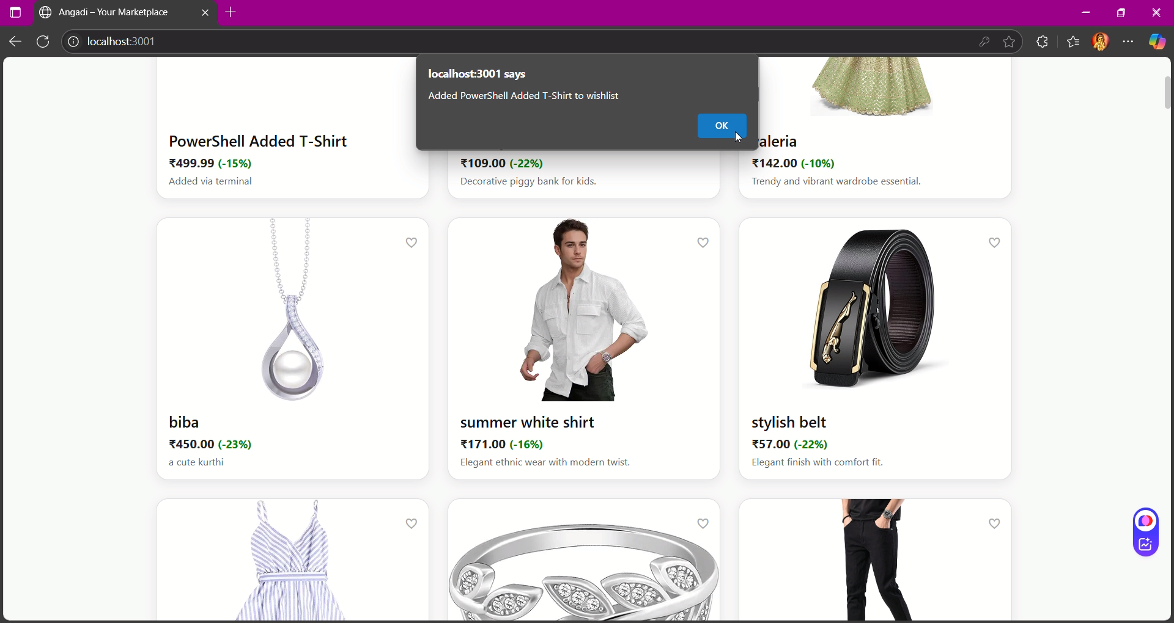
- As you can see if you add any product to wishlist
- 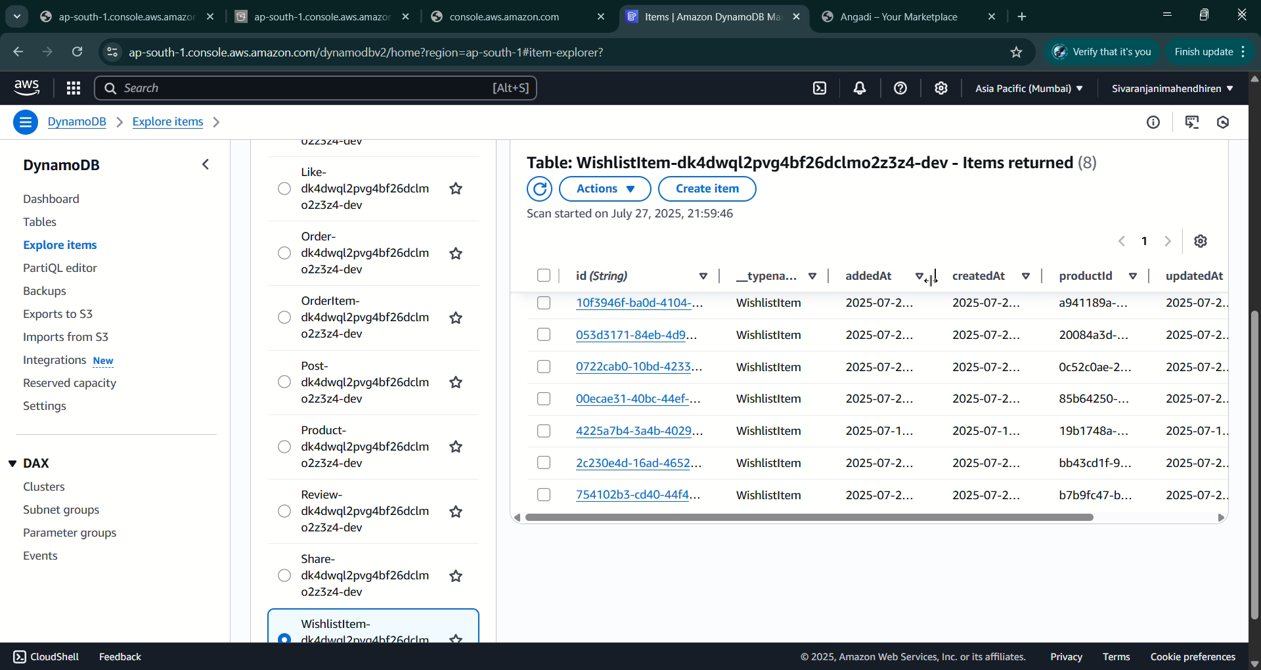
- Added the details to the prior table via connectivity 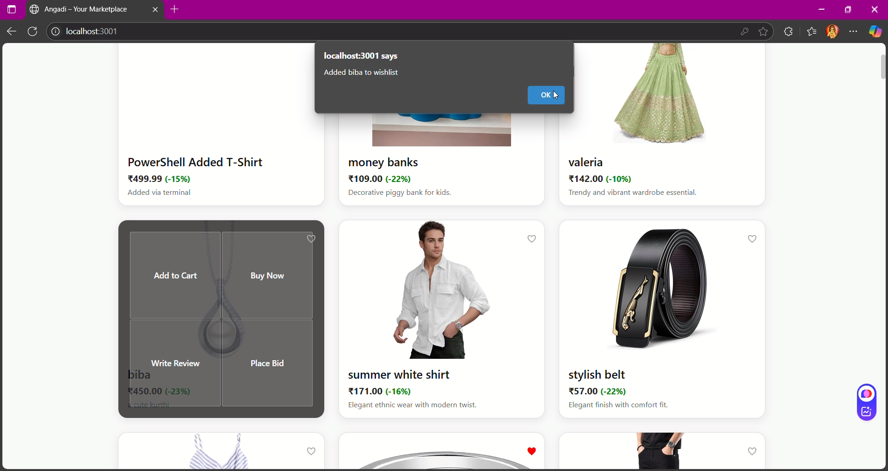
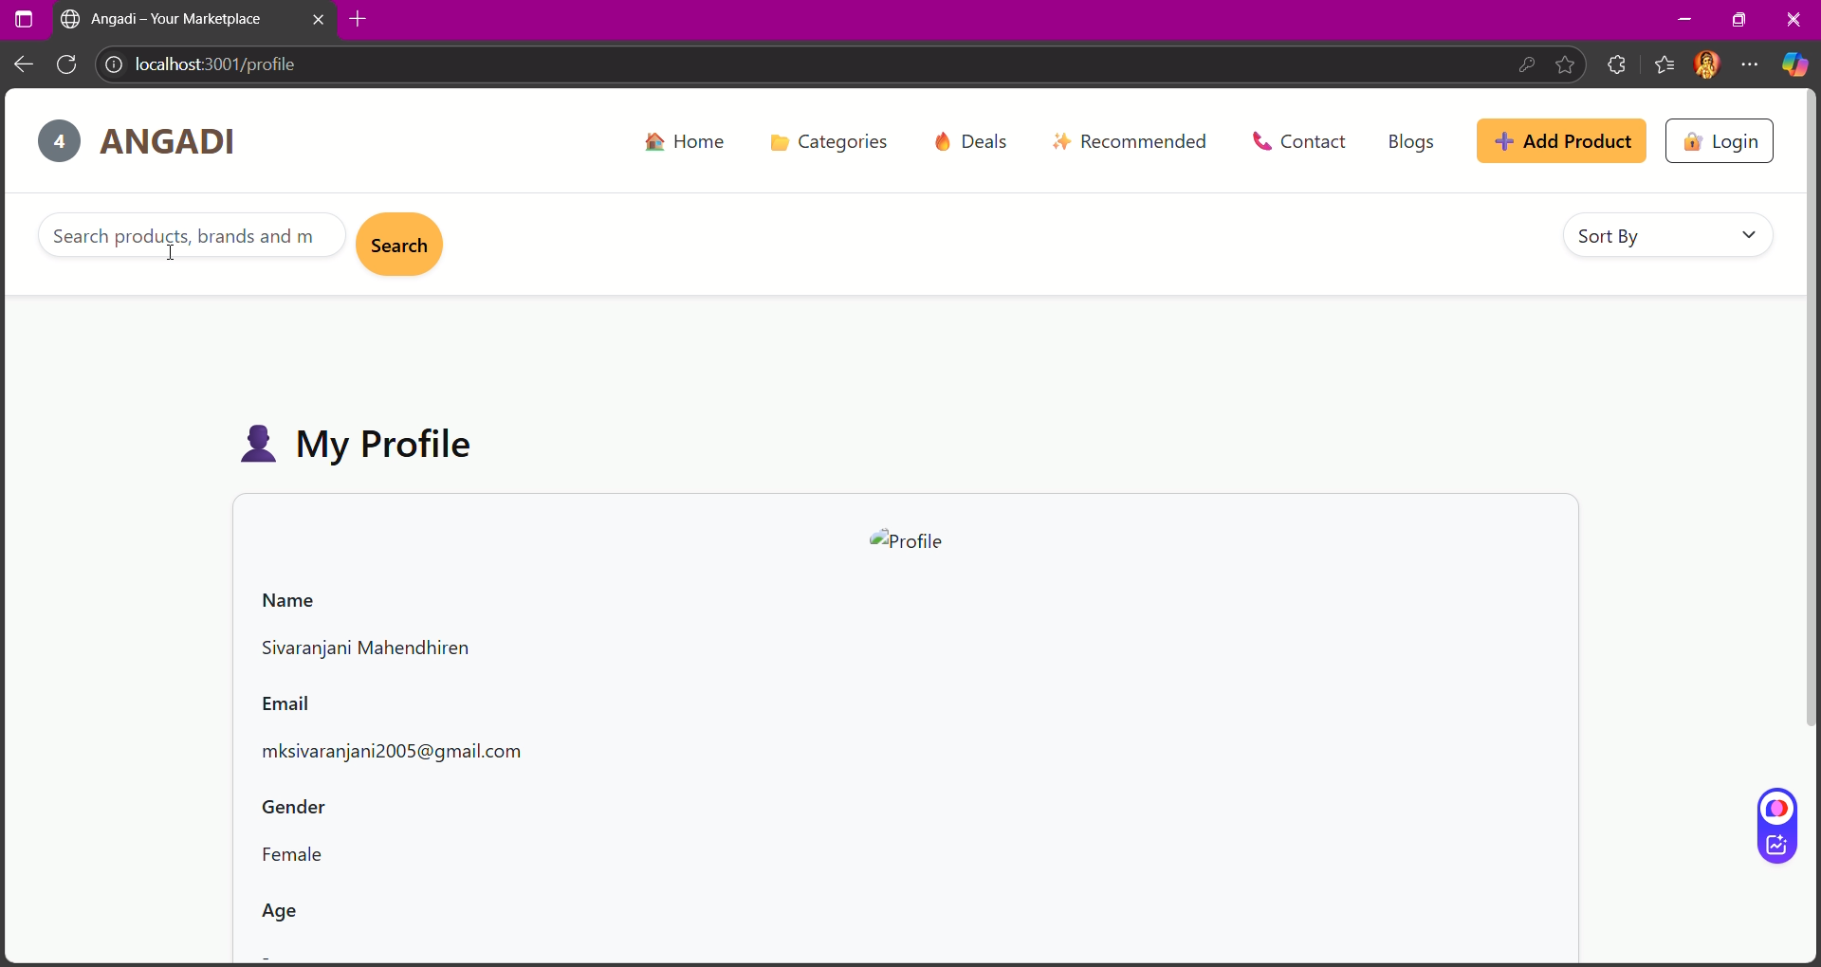
You can see your profile details here in this section
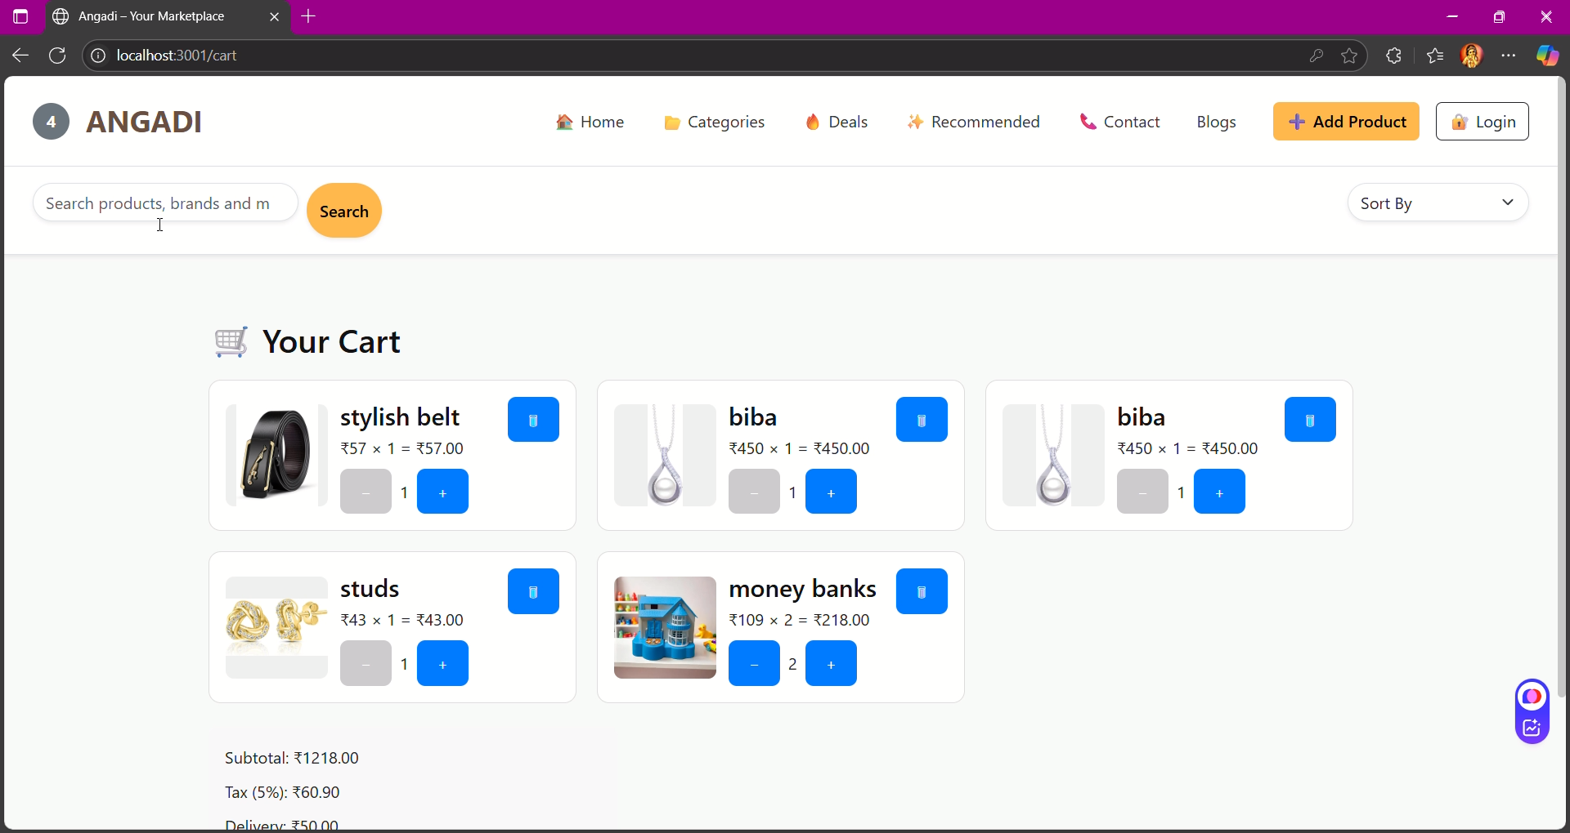
This is the cart section you can see the products added to the cart.
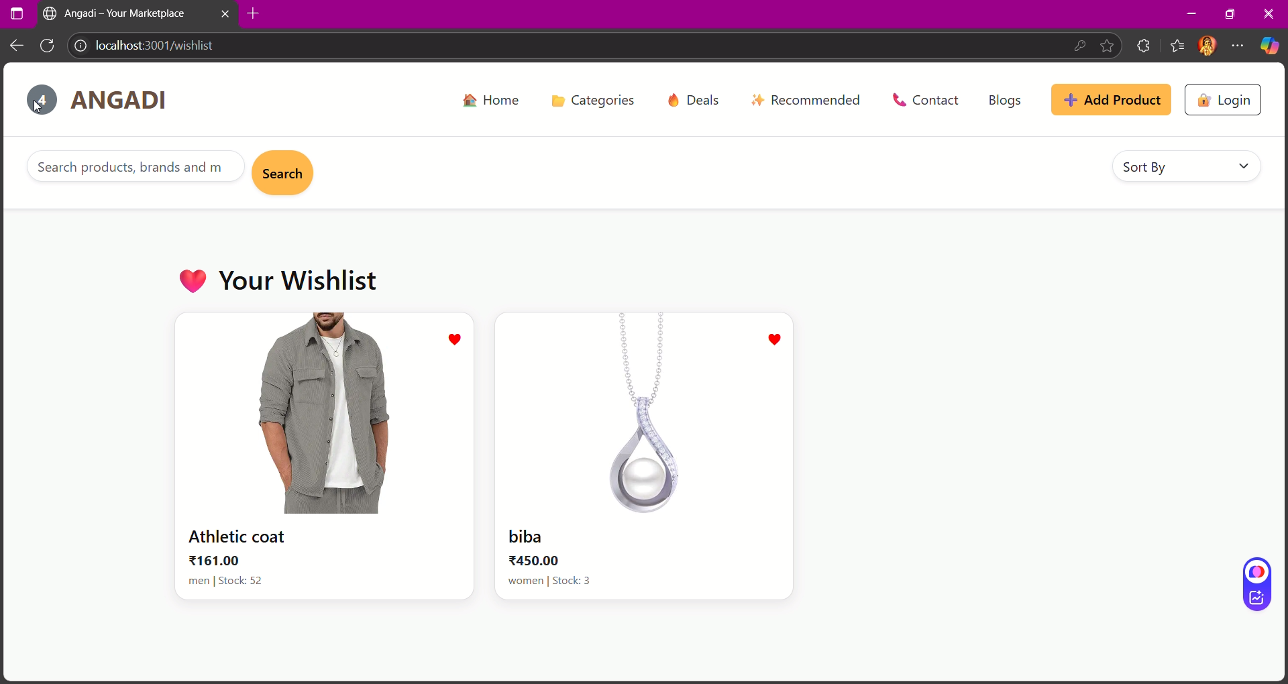
This section about the wishlisting products , what you wish to add you can add and view here in this section easily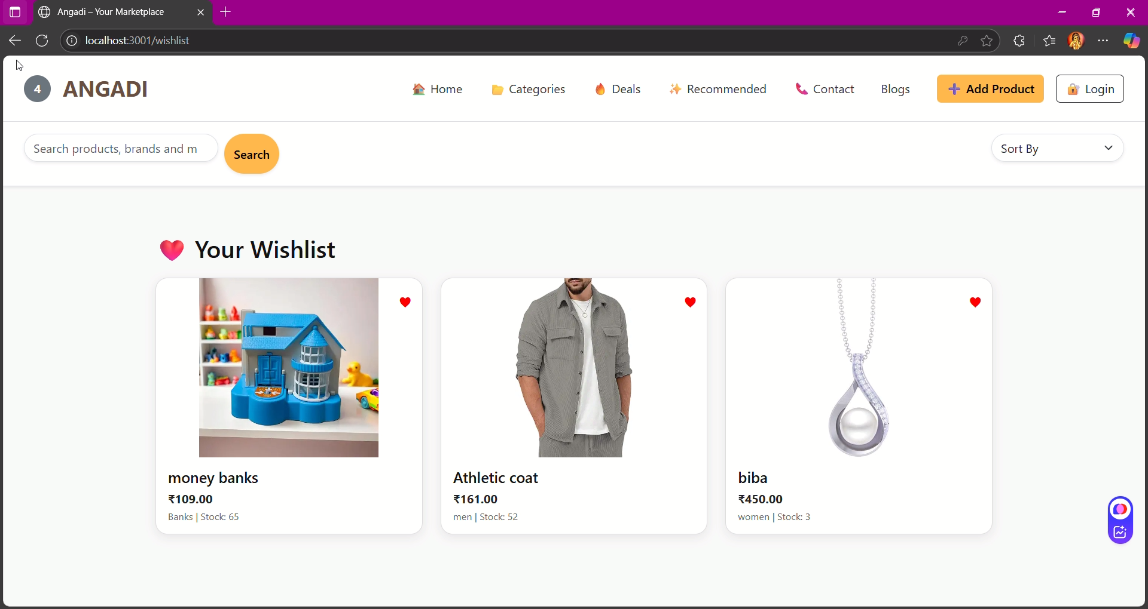 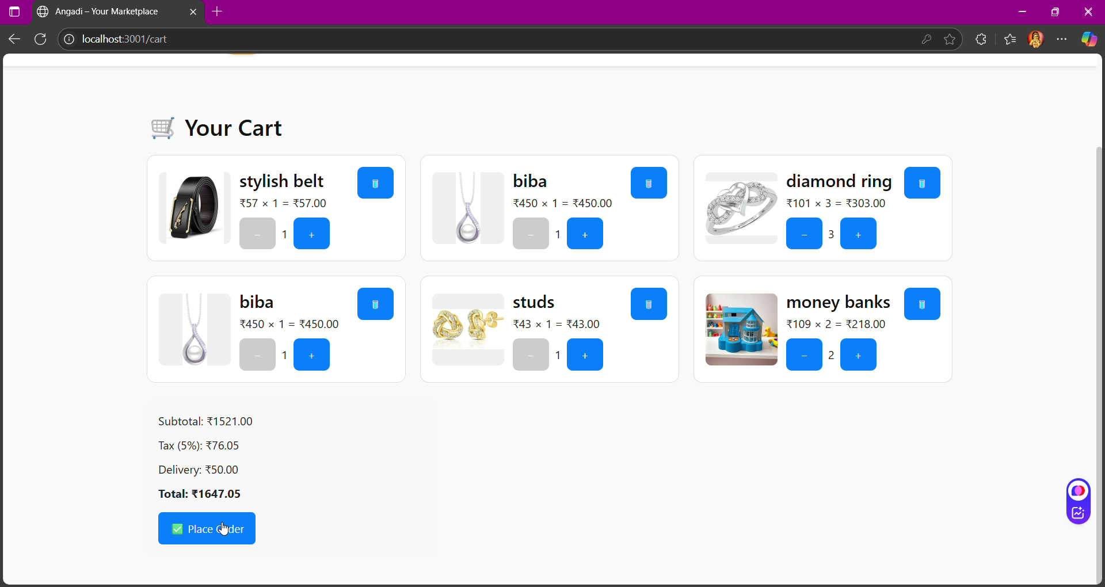 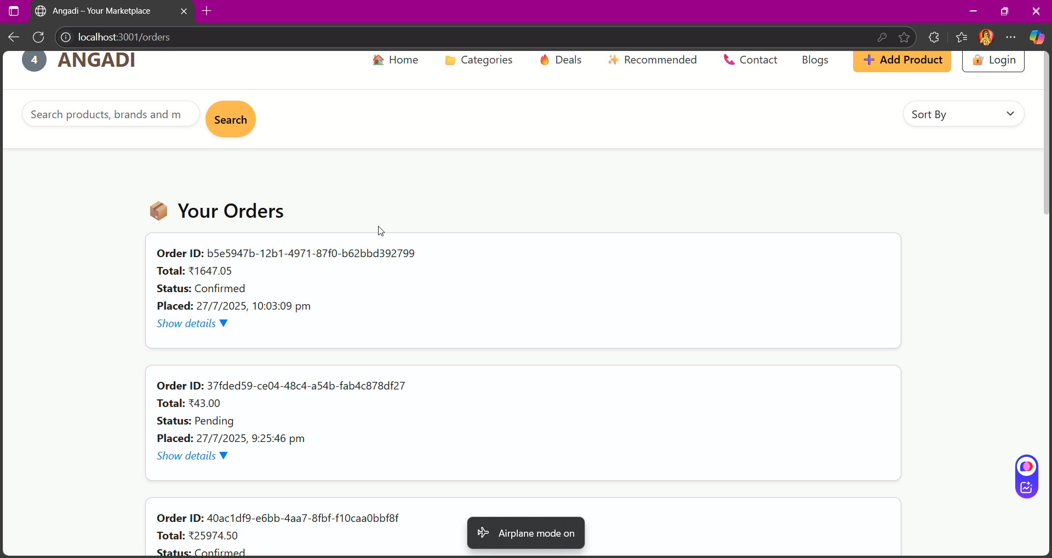
This is the orders section where you can glide over the orders we have made .
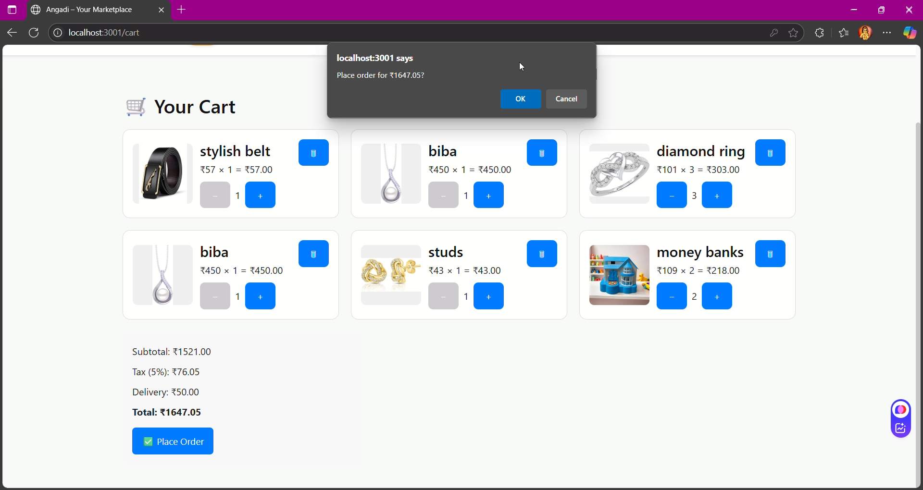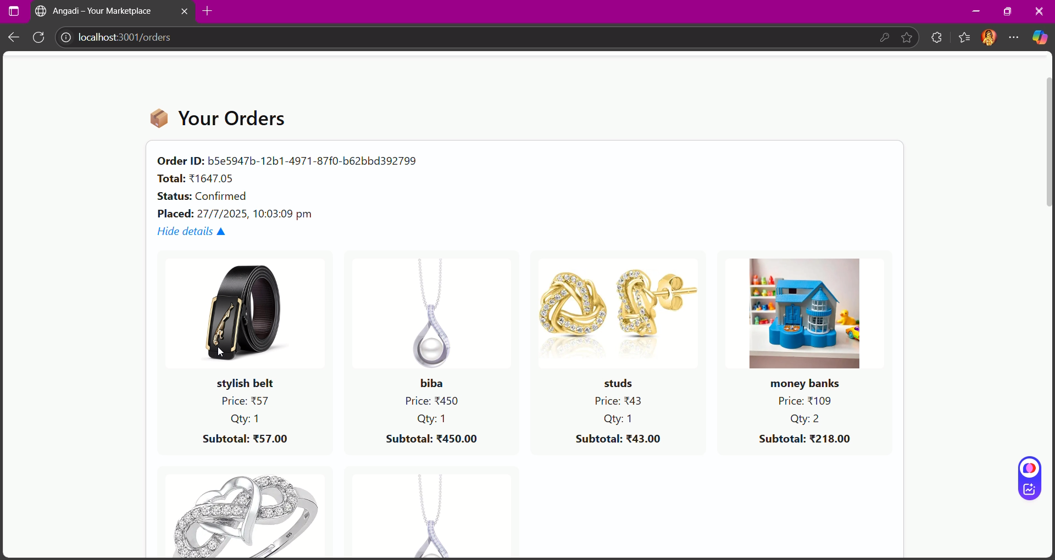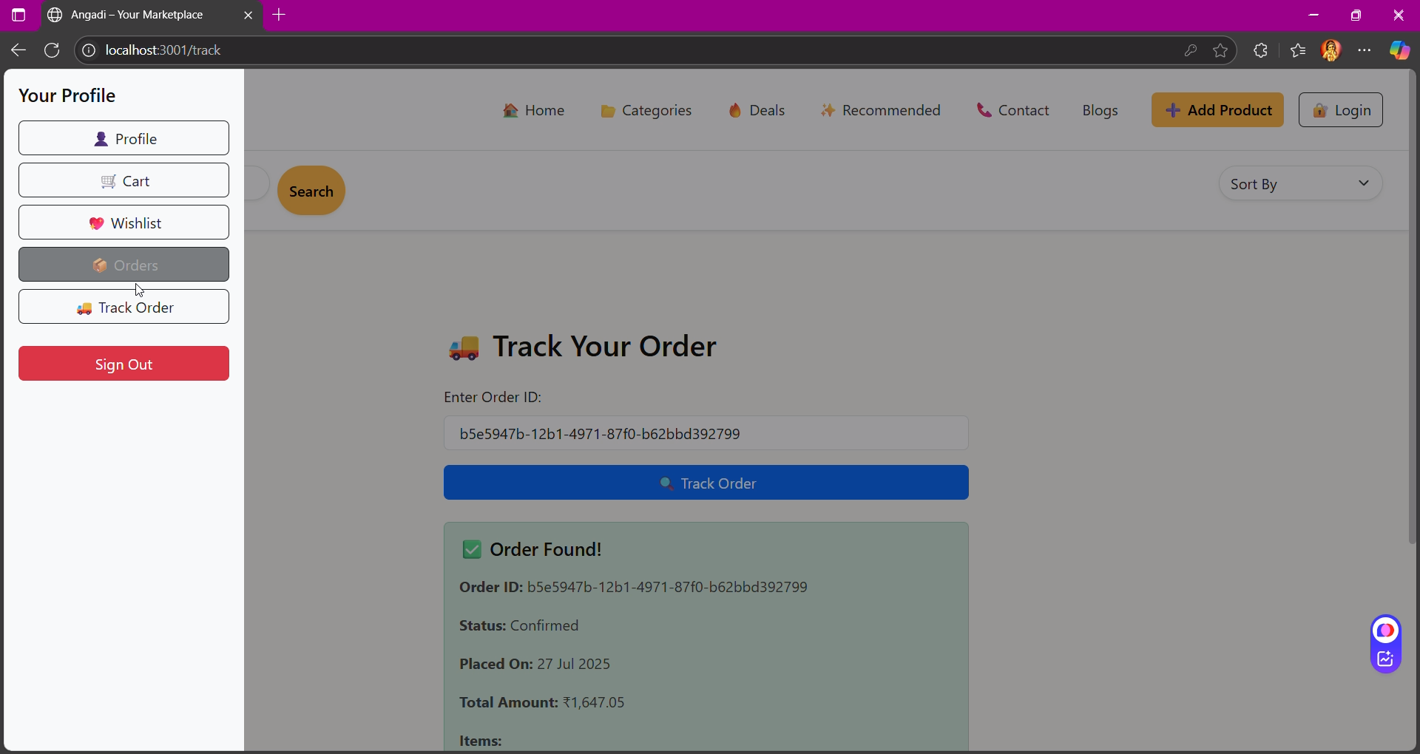
In this section of track your order, you can track the status of order and deliveries everything
- 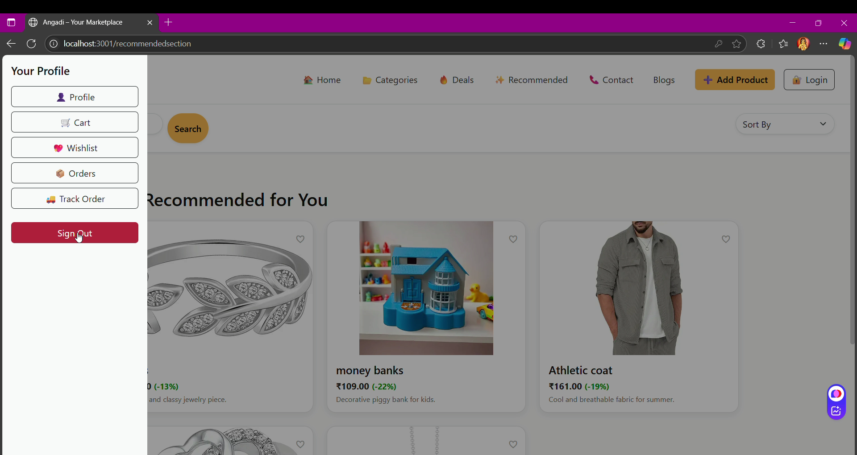
- If you need you can logout too.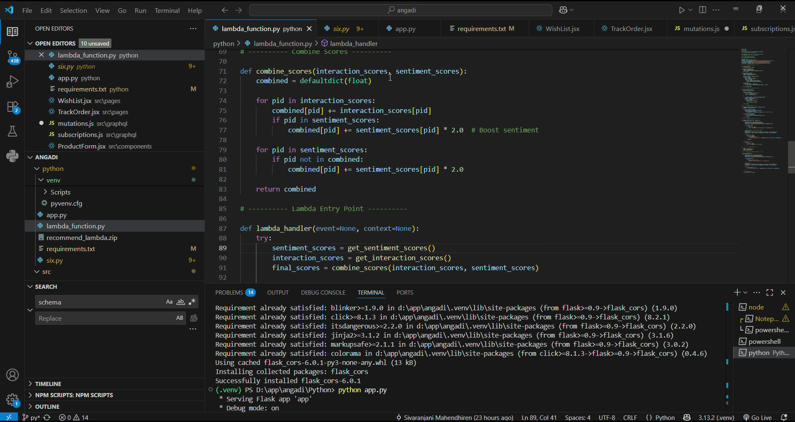
Project GitHub Link
https://github.com/sure-trust/SIVARANJANI-MAHENDHIREN-g5-cc.git

Learning and Reflection
Document member’s new learnings (in terms of technology, management, etc)
1. Technical Learnings
- Gained hands-on experience with AWS services (Amplify, S3, Lambda, API Gateway).
- Learned React.js for building responsive and interactive front-end.
- Implemented Flask for backend microservices and API handling.
- Worked with Docker & Jenkins for CI/CD pipeline creation.
- Integrated OpenAI API for chatbot functionality.
- Understood data collection, storage, and preprocessing methods for predictive analysis.
2. Management Learnings
- Managed end-to-end project workflow independently.
- Improved time management by handling multiple modules parallelly.
- Learned documentation and presentation skills for clear communication.
- Enhanced ability to plan and execute a project from scratch.
3. Problem-Solving & Analytical Learnings
- Debugged multiple integration errors across frontend, backend, and cloud services.
- Enhanced ability to map user requirements into technical workflows.
- Improved analytical thinking in designing data pipelines and prediction modules.
4. Personal Development
- Learned to self-learn new tools and technologies quickly.
- Developed confidence in handling solo projects.
- Strengthened ability to think both technically and strategically for real-world applications.

Document member’s experience.

As the sole contributor to the project, I gained end-to-end ownership experience by handling all aspects of design, development, integration, and deployment. I enhanced my technical proficiency in full-stack development, cloud services, and CI/CD practices, while also strengthening my problem-solving and decision-making skills.
The project allowed me to work on requirement analysis, workflow design, system architecture, implementation, and testing, which helped me understand the complete lifecycle of a real-world application. Additionally, I developed time management, adaptability, and self-driven learning skills, ensuring the project was executed efficiently without external dependency.
This experience not only improved my technical depth across multiple technologies but also provided practical exposure to project management and ownership, preparing me for handling complex, large-scale professional projects in the future.

Conclusion and Future Scope
Recap objectives and achievements
Objectives:
- Develop a complete end-to-end project independently.
- Gain hands-on expertise in full-stack development and cloud integration.
- Implement secure, efficient, and scalable workflows.
- Strengthen project ownership, problem-solving, and time management skills.
Achievements:
- Successfully designed, developed, and deployed the project single-handedly.
- Enhanced technical expertise in React, AWS, CI/CD, and integration workflows.
- Delivered a fully functional, scalable, and efficient solution meeting all requirements.
- Built strong self-reliance, adaptability, and decision-making capabilities.

Future scope of this project
- Feature Expansion: Add advanced analytics dashboards, AI-driven recommendations, and predictive alerts.
- Scalability: Enhance multi-user support, load balancing, and cross-platform compatibility.
- Automation: Integrate advanced CI/CD, container orchestration (Kubernetes), and monitoring tools.
- Security: Strengthen authentication, data privacy, and compliance with industry standards.
- User Experience: Improve UI/UX with personalized workflows and mobile-friendly design.
- Integration: Extend APIs for third-party services, payment gateways, and external systems.

